**Information Technology Department**

**State Polytechnic of**

**Malang**

**Exercise**

**1**

**Course:**

**Object Based Programming**



|  |  |
| --- | --- |
| **Name** | **: SAFRIZAL RAHMAN** |
| **Class** | **: 2G SIB** |
| **NIM** | **: 2341760151** |

1. RakServer

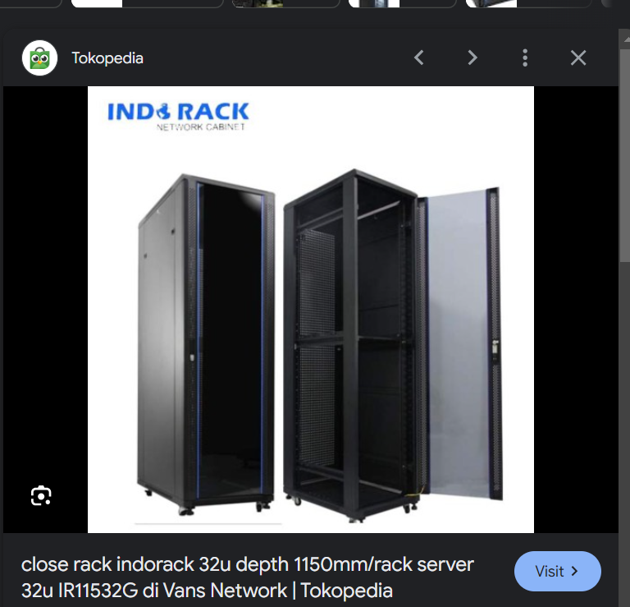

State (Attributes):

- Brand

- Capacity

- Number of Servers

- Status

- Location

Behavior (Methods):

- Add Server

- Remove Server

- Check Status

- Move Location

1. iPad

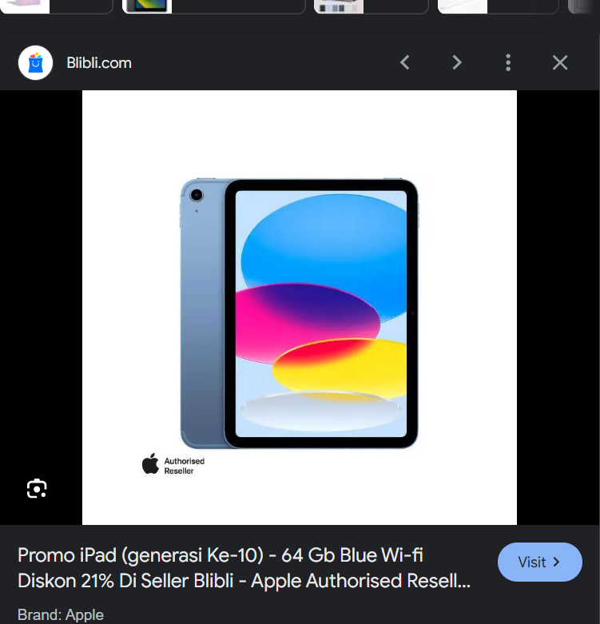

State (Attributes):

- Brand

- Model

- Battery Level

- Operating System

- Screen Size

- Storage Capacity

- Network Connection

- Camera Resolution

Behavior (Methods):

- Turn On

- Turn Off

- Open App

- Take Photo

- Adjust Volume

- Charge Battery

- Connect to Internet

- Lock Screen

- Unlock Screen

3. Monitor

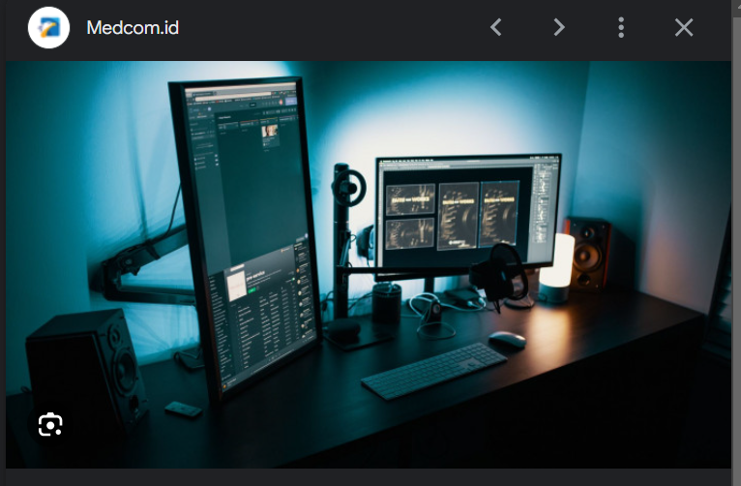

State (Attributes):

- Brand

- Screen Size

- Resolution

- Refresh Rate

- Input Ports

- Power Status

- Stand/bracket

Behavior (Methods):

- Turn On

- Turn Off

- Adjust Brightness

- Change Input Source

- Adjust Volume

- Adjust position

1. RJ45

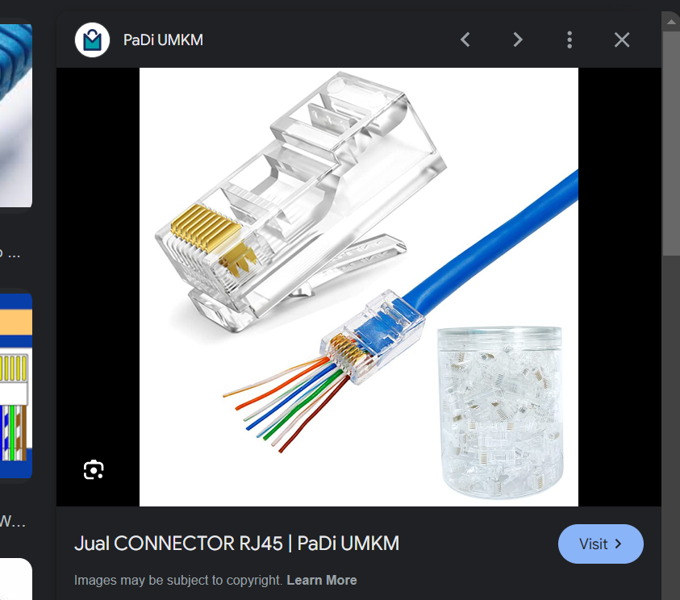

State (Attributes):

- Cable Type

- Length

- Connector Type

- Color

- Shielding

Behavior (Methods):

- Connect

- Disconnect

- Test Connection

- Crimp

5. Nvidia RTX

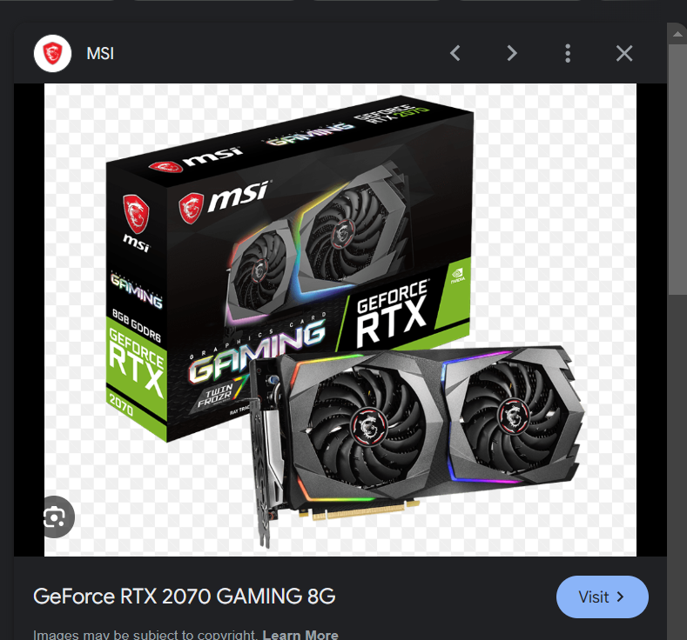

State (Attributes):

- Model

- Memory Size

- Core Clock Speed

- Memory Type

- Power Consumption

- Cooling Type

Behavior (Methods):

- Render Graphics

- Perform Computations

- Adjust Fan Speed

- Monitor Temperature

- Update Drivers

|  |
| --- |
| RakServer |
| brand: String  capacity: int  numberOfServers: int  status: String  location: String |
| addServer(server: Server): void  removeServer(server: Server): void  checkStatus(): String  moveLocation(newLocation: String): void |
|  |
|  |



|  |
| --- |
| iPad |
| brand: String  model: String  batteryLevel: int  operatingSystem: String  screenSize: float  storageCapacity: int  networkConnection: String  cameraResolution: int |
| turnOn(): void  turnOff(): void  openApp(appName: String): void  takePhoto(): void  adjustVolume(level: int): void  chargeBattery(): void  connectToInternet(): void  lockScreen(): void  unlockScreen(): void |



|  |
| --- |
| Monitor |
| brand: String  screenSize: float  resolution: String  refreshRate: int  inputPorts: String  powerStatus: String  Stand/Bracker: String |
| turnOn(): void  turnOff(): void  adjustBrightness(level: int): void  changeInputSource(source: String): void  adjustVolume(level: int): void  AdjustPosition:void |
|  |
|  |



|  |
| --- |
| NvidiaRTX |
| model: String  memorySize: int  coreClockSpeed: float  memoryType: String  powerConsumption: int  coolingType: String |
| renderGraphics(): void  performComputations(): void  adjustFanSpeed(speed: int): void  monitorTemperature(): void  updateDrivers(): void |
|  |



|  |
| --- |
| RJ45 |
| cableType: String  length: float  connectorType: String  color: String  shielding: String |
| connect(): void  disconnect(): void  testConnection(): void  crimp(): void |
|  |
|  |

